# Lab 6:

**Serial Communications, USART Module, RS232 Standard**

**Name (Print):** ____________________________________________________ID______________  
  
**Give brief answers to the following questions. You can edit this document and insert your answers after each question.**

**Due dates:**

**MW – Wed, Mar 28, beginning of class  
TTH – Tue, Mar 27, beginning of class**

**Circle one: MW or TTH**

1. (1 pt) What word is formed by the following ASCII codes?  
     
   75h – 62h – 69h – 71h – 75h – 69h – 74h – 6Fh – 75h – 73h   
     
   **Ans.**
2. (1 pt) What is “bit banging” ?  
     
   **Ans.**
3. (1 pt) Express the decimal number 492710 in binary coded decimal (BCD), binary, and hex.  
     
   **Ans.**  
   492710 = 492710 =   
     
   492710 =
4. (1 pt) What is a **null modem** RS-232 cable? Is the cable that was supplied in your parts kit for this lab a null modem? How can you test this?  
     
   **Ans.**
5. (1 pt) We learned in class that the RS232 pins 2, 3, and 5 on a DB9 connector are used for receive, transmit, and ground. What are the other pins used for?  
     
   **Ans.**  
   1: 4:  
     
   6: 7:  
     
   8: 9:
6. (1 pt) What is the difference between the terms **baud rate** (or baud) and **bit rate**.  
     
   **Ans.**
7. (1 pt) According to the data sheet, what causes a **framing error**? Which bit (bit number and mnemonic) in which register is set when a framing error occurs?  
     
   **Ans.**
8. (1 pt) What special kind of register is RCREG? What causes an overrun error?  
     
   **Ans.**
9. (1 pt) Suppose a PIC with a baud rate of 9681 bps is transmitting to another PIC with a baud rate of 9581 bps. What is the maximum percentage error between the two rates? Will this result in framing errors? Explain your answer.  
     
   **Ans.**
10. (1 pt) According to the Guinness Book of World Records, *A la recherche du temps perdu* by Marcel Proust is the world’s longest novel. Suppose the PIC is configured to transmit ASCII text at 19200 baud.

a) How many characters are transmitted per second?  
  
**Ans.**

b) At this rate, how many minutes would it take to transmit the world’s longest novel?

**Ans.**

1. (2 pts) Suppose you have a PIC with *Fosc* = 10 MHz. If BRGH = 1, what value of SPBRG should you use if you want to communicate at 57600 baud? What is the actual baud rate that you will achieve with this value of SPBRG? What is the resulting percent error in your baud rate? Will this cause communication errors? Repeat for BRGH = 0.  
     
   **Ans.**

**BRGH = 1:**

a)  
  
  
  
b)   
  
  
c)

d)

**BRGH = 0:**a)  
  
  
  
b)   
  
  
c)

d)

1. (1 pt) What is the hex value and the equivalent ASCII character of the W register after the following sequence of instructions?  
     
   movlw “@”  
   addlw “?”  
     
   **Ans.**
2. (2 pts) Suppose an RS232 line has noise such that there is a 1.5 % chance of reading a bit value incorrectly. What is the probability of reading **at least** two out of three bit values correctly? Give the answer to six decimal places. (Hint: This is a Binomial Experiment – *k* successes in *n* trials. Note the “at least” in bold.)  
     
   **Ans.**
3. (2 pts) Communication between the PIC and the MAX202 transceiver is achieved using the TTL protocol which uses +5 V for logic 1, and 0 V for logic 0. Communication between the MAX202 transceiver and the PC is achieved using the RS232 protocol. According to the MAX202 data sheet from Maxim Integrated Inc, what are the voltage levels corresponding to logic 1 and logic 0 for the RS232 transmitter output and the RS232 receiver input ? What is the maximum data rate?  
     
    (Hint: You should list two voltage levels for the RS232 input and two voltage levels for the RS232 output. The current RS232 standard is referred to as the EIA/TIA-232E specification in the data sheet.)   
   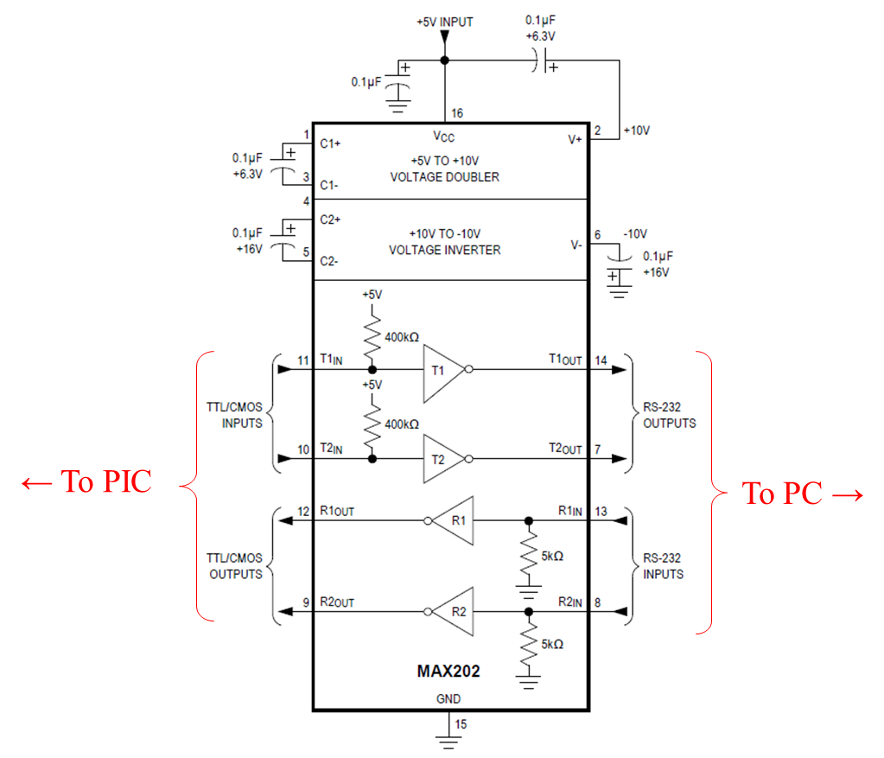  
     
   **Ans.**   
     
   RS232 Driver Output Voltage: 0 Level:

RS232 Driver Output Voltage: 1 Level:   
  
RS232 Receiver Input Voltage: 0 Level:

RS232 Receiver Input Voltage: 1 Level:   
  
Maximum data rate =

1. (10 pts) Create a new project based on lab06a.asm called lab06a_modified. Modify the program so that each time a button on the breadboard is pressed, a counter in the PIC increments and the value of the counter is transmitted to, and displayed by, the PC serial port program on the PC. The program should initially display “0” on the PC, and increment through the digits until “9” is displayed. After “9” is displayed, the next time the button is pushed “0” should displayed, and then the sequence should repeat. Demonstrate and explain the program to the instructor or TA.

**Student Name** ____________________________________________________________

**Instructor/TA signature** _________________________________ **Date**_____________

1. (5 pts) Demonstrate lab06b to the instructor or TA and explain how the code works.

**Instructor/TA signature** _________________________________ **Date**_____________